**INTELLIGENT SYSTEM WEEK 2 ASSIGNMENT**

**Michael Christopher**

**2440047362**

Exercise 1

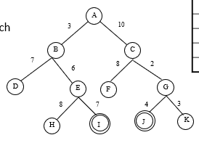

1. Breadth-First Search

| Visited Node | Node List |
| --- | --- |
|  | {A} |
| A not goal | {B, C} |
| B not goal | {C, D, E} |
| C not goal | {D, E, F, G} |
| D not goal | {E, F, G} |
| E not goal | {F, G, H, I} |
| F not goal | {G, H, I} |
| G not goal | {H, I, J, K} |
| H not goal | {I, J, K,} |
| I is goal | {J, K} |

Path: A, B, E, I  
Cost: 16

1. Depth-First Search

| Visited Node | Node List |
| --- | --- |
|  | {A} |
| A not goal | {B, C} |
| B not goal | {D, E, C} |
| D not goal | {E, C} |
| E not goal | {H, I, C} |
| H not goal | {I, C} |
| I is goal | {C} |

Path: A, B, E, I

Cost: 16

1. IDS

| Visited Node | Node List |
| --- | --- |
|  | {A} |
| A not goal | {B, C} |
| B not goal | {C} no expand |
| C not goal | {} no expand |
| A no test | {B, C} |
| B no test | {D, E, C} |
| D not goal | {E, C} no expand |
| E not goal | {C} no expand |
| C no test | {F, G} |
| F not goal | {G} no expand |
| G not goal | {} no expand |
| D no test | {} |
| E no test | {H, I} |
| H not goal | {I} no expand |
| I is goal | {} no expand |

Path: A, B, E, I

Cost: 16

1. Uniform Cost Search

| Visited Node | Node List |
| --- | --- |
|  | {A:0} |
| A not goal | {B:3 , C:10} |
| B not goal | {E:9, D:10, C:10} |
| E not goal | {D:10, C:10, I:16, H:17} |
| D not goal | {C:10, I:16, H:17} |
| C not goal | {G:12, I:16, H:17, F:18} |
| G not goal | {K:15, J:16, I:16, H:17, F:18} |
| K not goal | {J:16, I:16, H:17, F:18} |
| J is goal | {I:16, H:17, F:18} |

Path: A, C, G, J

Cost: 16

Heuristic Exercise:

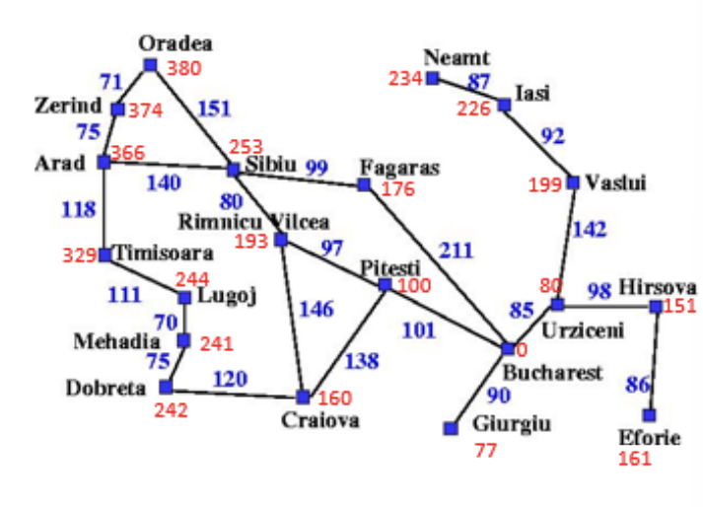

1. Greedy Search

| Expand node | OPEN list |
| --- | --- |
|  | {Arad: 336} |
| Arad not goal | {Sibiu: 253, Timisoara: 329, Zerind: 374} |
| Sibiu not goal | {Fagaras: 176, Rimnicu Vilcea: 193, Timisoara: 329, Zerind: 374, Oradea: 380} |
| Fagaras not goal | {Bucharest: 0, Rimnicu Vilcea: 193, Timisoara: 329, Zerind: 374, Oradea: 380} |

Path: Arad, Sibiu, Fagaras, Bucharest

Cost: 450

1. A* search

| Expand node | OPEN list |
| --- | --- |
|  | {Arad: 336} |
| Arad not goal | {Sibiu: 393, Timisoara: 447, Zerind: 449} |
| Sibiu not goal | {Rimnicu Vilcea: 273, Fagaras: 275, Timisoara: 329, Zerind: 449, Oradea: 531} |
| Rimnicu Vilcea not goal | {Pitesti: 197, Fagaras: 275, Timisoara: 329, Craiova: 306, Zerind: 449, Oradea: 531} |
| Pitesti not goal | {Bucharest: 101, Fagaras: 275, Timisoara: 329, Craiova: 306, Zerind: 449, Oradea: 531} |
| Bucharest is goal | {Fagaras: 275, Timisoara: 329, Craiova: 306, Zerind: 449, Oradea: 531} |

Path: Arad, Sibiu, Rimnicu Vilcea, Pitesti, Bucharest

Cost: 418

-Optional Exercise

| S | 12 | 14 | 16 | 22 |
| --- | --- | --- | --- | --- |
| 1 | 10 | G | 19 | 20 |
| 2 | 8 | 23 | 21 | 17 |
| 3 | 5 | 7 | 18 | 15 |
| 4 | 6 | 9 | 11 | 13 |

Search Tree:

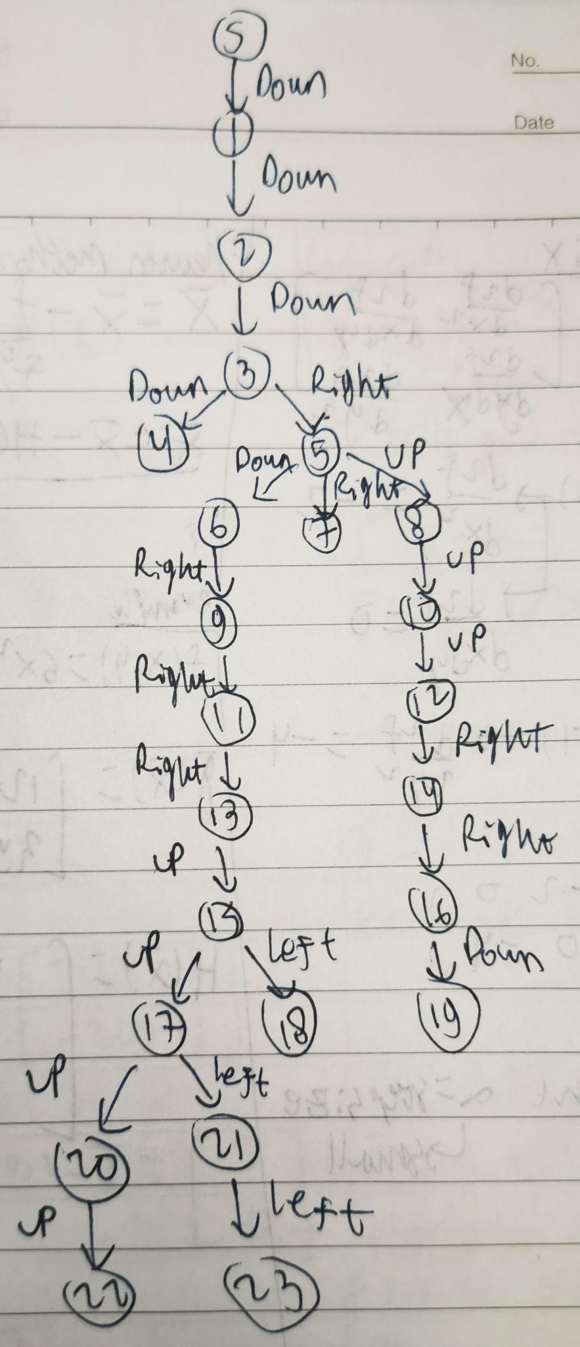

DFS:

S, 1, 2, 3, 4, 5, 6, 9, 11, 13, 15, 17, 20, 22, 21, 23, 18, 7, 8, 10, 12, 14, 16, 19, G

BFS:

S, 1, 2, 3, 4, 5, 6, 7, 8, 9, 10, 11, 12, 13, 14, 15, 16, 17, 18, 19, 20, 21, G